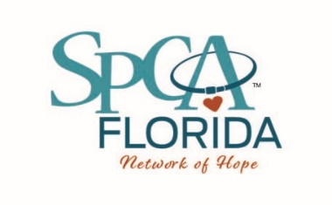
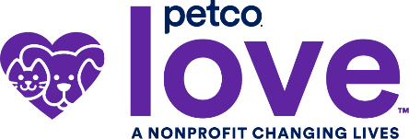

Media Contact:
Randa Richter
Humane Programs & Public Media Director
O: (863) 577-4608
rrichter@spcaflorida.org
Petco Love
media@petcolove.org

PETCO LOVE AND SPCA FLORIDA ENCOURAGE PET FOSTERING
WITH A FOCUS ON FUN
Nonprofit organizations partner for National Foster a Pet Month to encourage more pet parents to lend a (temporary) hand or home to pets in need during busy summer season

Lakeland, FL (June 16, 2022) – SPCA Florida is teaming up with national nonprofit Petco Love and Skechers with its BOBS from Skechers philanthropic footwear collection, to put the focus on the fun in fostering pets. Pet fostering is lifesaving and critical for animal shelters particularly during the busy summer season.
“Ending preventable euthanasia of shelter pets is possible today,” said Susanne Kogut, president of Petco Love. “Data tells us that if we could encourage 2% more of the 85-million pet-owning households to foster just one pet a year, we can eliminate preventable euthanasia and save the lives of the 800,000 shelter animals at risk of euthanization in the U.S. annually.”

But fostering can be serious fun, too.

Throughout June, Petco Love will work with its network of partners nationwide to share the fun aspects of fostering while helping pet parents groove through their foster pet goodbyes. In fact, saying goodbye to foster pets – and the fear they’ll struggle giving the pet to a new family – is among the most-cited reasons why pet parents don’t foster.

Petco Love is taking a humorous approach to saying goodbye to foster pets by holding a #MyFosterBreakUp story contest featuring Foster Breakup Kits giveaways and a curated playlist to help foster pet parents through their goodbyes.

Kits include breakup essentials: cozy, festive socks from BOBS from Skechers, a pint of Ben & Jerry’s Ice Cream, Kleenex, the official Petco Love Foster Breakup Spotify Playlist, and a foster tee that reminds you that “Foster Pets are Here for A Fun Time, Not a Long Time.” Foster parents can enter to win by sharing their breakup letter from their foster pet on Instagram using the hashtag #MyFosterBreakUp from June 1 –30 and even win $10,000 in lifesaving funds for the organization they foster from.

SPCA Florida will also join shelters nationwide for the National Foster Pet Open House event by inviting the public to visit the shelter located at 5850 Brannen Rd S. in Lakeland, Florida on Saturday, June 25th from 12 – 3 p.m. for an interactive foster meet-and-greet party for two-and four-legged friends.

SPCA Florida's foster open house event will include games, crafts, information booths on how to become a foster parent, and light refreshments.

“Fostering is vital to our community’s lifesaving efforts,” said Shelley Thayer, Executive Director of SPCA Florida. “Through our partnership with Petco Love, we’re excited to take part in National Foster a Pet Month and build on this event’s positive momentum to help save more lives year-round.”

Establishing June as National Foster a Pet Month to increase participation in fostering is just one of the lifesaving actions led by Petco Love in their 23-year history of helping pets, with $330 million invested in lifesaving efforts and 6.5 million pets adopted – and counting. Skechers has contributed more than $8 million to help over 1.5 million shelter pets, including saving 1.1 million rescued pets in the United States and Canada.

The nonprofit also recently launched a new national database, Petco Love Lost, which uses pet facial recognition technology to help reunite missing pets with their families.

To learn more about SPCA Florida and their upcoming event, please visit spcaflorida.org/.

To learn about Petco Love and to view foster resources, visit petcolove.org/foster and join the conversation on Facebook, Twitter and Instagram using #PetcoLoveFoster.
For more on BOBS from Skechers, visit BOBSfromSkechers.com.

About SPCA Florida
Founded in 1979, SPCA Florida exists to eliminate animal suffering and engage the entire community in the welfare and well-being of animals. SPCA Florida will help and heal 20,000 dogs and cats through its SPCA Florida Animal Medical Center and provide direct care for 6,500 animals through its Adoption Center this year. Ani-Meals and Food Assistance Programs provide food and medical care for animals of homebound families and families who need supplemental food for thousands of dogs and cats each year.

About Petco Love
Petco Love is a life-changing nonprofit organization that makes communities and pet families closer, stronger, and healthier. Since our founding in 1999 as the Petco Foundation, we’ve empowered animal welfare organizations by investing $330 million in adoption and other lifesaving efforts. We’ve helped find loving homes for more than 6.5 million pets in partnership with Petco and organizations nationwide.

Our love for pets drives us to lead with innovation, creating tools animal lovers need to reunite lost pets, and lead with passion, inspiring and mobilizing communities and our more than 4,000 animal welfare partners to drive lifesaving change alongside us. Join us. Visit petcolove.org or follow on Facebook, Instagram, Twitter, and LinkedIn to be part of the lifesaving work we lead every day.

